redirect

redirect() is an in-built function which is used to call a view by another view.
Redirect() send response to browser and browser send request to given view.

Syntax: redirect(“view name”)

Redirect return HttpResponse

Student manager application

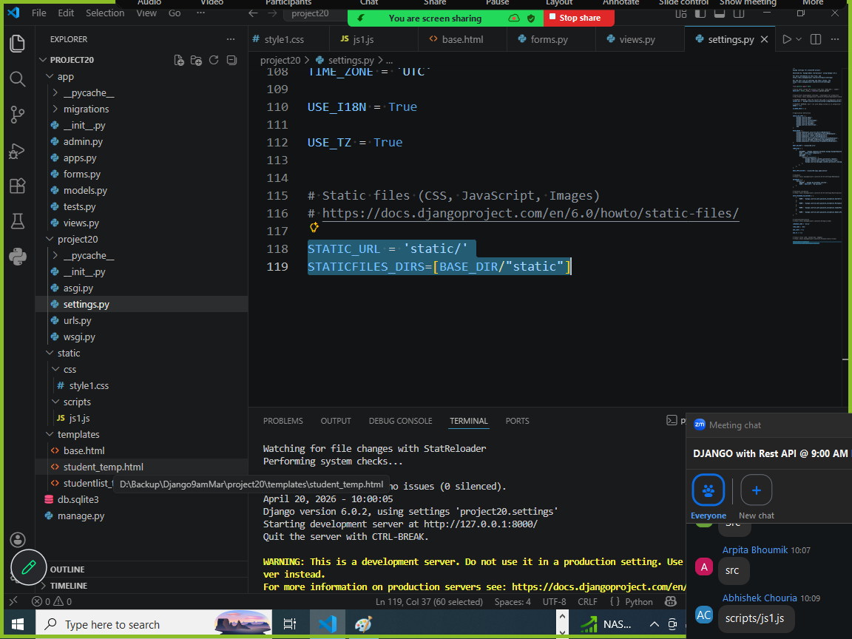

Models.py
from django.db import models

# Create your models here.

class Student(models.Model):
name=models.CharField(max_length=20,primary_key=True)
age=models.IntegerField()
email=models.EmailField()

forms.py

from app.models import Student
from django import forms
class StudentForm(forms.ModelForm):
class Meta:
model=Student
fields="__all__"

views.py

from django.shortcuts import render,redirect
from app.forms import StudentForm
from app.models import Student
# Create your views here.

def create_student(request):
form=StudentForm(request.POST or None)
if form.is_valid():
form.save()
response=redirect("studentlist")
return response
response=render(request,"student_temp.html",context={'form':form})
return response

def student_list(request):
qs=Student.objects.all()
response=render(request,"studentlist_temp.html",context={'qs':qs})
return response

def update_student(request,name):
if request.method=="GET":
stud=Student.objects.get(name=name)
student={'name':stud.name,'age':stud.age,'email':stud.email}
form=StudentForm(student)
response=render(request,"student_temp.html",context={'form':form})
return response
else:

stud=Student.objects.get(name=name)
form=StudentForm(request.POST,instance=stud)
if form.is_valid():
form.save()
response=redirect("studentlist")
return response
response=render(request,"student_temp.html",context={'form':form})
return response

def delete_student(request,name):
stud=Student.objects.get(name=name)
stud.delete()
response=redirect("studentlist")
return response

urls.py

from django.contrib import admin
from django.urls import path
from app.views import student_list,create_student,update_student,delete_student
urlpatterns = [
path('admin/', admin.site.urls),
path('studentlist/',student_list,name='studentlist'),
path('create_student/',create_student,name='create_student'),
path('student_update/<str:name>/',update_student,name='student_update'),
path('student_delete/<str:name>/',delete_student,name='student_delete'),

]

Student_temp.html
{%extends 'base.html'%}
{%block content%}
<form method="post">
{%csrf_token%}
<table>
{{form.as_table}}
<tr>
<td><input type="submit" value="Save"></td>
</tr>
</table>
</form>
<a href="/studentlist">List of Students</a>
{%endblock%}

Base.html
{%load static%}
<!DOCTYPE html>
<html lang="en">
<head>
<meta charset="UTF-8">
<meta name="viewport" content="width=device-width, initial-scale=1.0">
<title>StudentManager</title>
<link rel="stylesheet" href="{%static '/css/style1.css'%}">
<script src="{%static '/scripts/js1.js'%}"></script>
</head>
<body>
{%block content%}
{%endblock%}
</body>
</html>

Studentlist_temp.html

{%extends 'base.html'%}
{%block content%}
<table>
<tr>
<th>Name</th>
<th>Age</th>
<th>Email</th>
<th>Actions</th>
</tr>
{%for row in qs%}
<tr>
<td>{{row.name}}</td>
<td>{{row.age}}</td>
<td>{{row.email}}</td>
<td>
<a href="{%url 'student_update' row.name %}">Edit</a>
<a href="{%url 'student_delete' row.name %}" onclick="return confirmDelete()">Delete</a>
</td>
</tr>
{%endfor%}
</table>
{%endblock%}

Styles1.css
body{
font-family: Arial, Helvetica, sans-serif;
margin: 40px;
}
table{
width:75%;
border-color: black;
border-width: 2px;
border-style: solid;

}
th,td{
padding: 10px;
text-align: center;
border-color: red;
border-width: 1px;
border-style: solid;
}
a{
margin: 5px;
}

Js1.js
function confirmDelete(){
return confirm("Are you sure want to delete?")
}

Settings.py
INSTALLED_APPS = [
'django.contrib.admin',
'django.contrib.auth',
'django.contrib.contenttypes',
'django.contrib.sessions',
'django.contrib.messages',
'django.contrib.staticfiles',
'app'
]

TEMPLATES = [
{
'BACKEND': 'django.template.backends.django.DjangoTemplates',
'DIRS': [BASE_DIR/"templates"],

STATIC_URL = 'static/'
STATICFILES_DIRS=[BASE_DIR/"static"]

Working with media files (OR) Media Files

What are media files in django?

In django media files is nothing user uploaded files.
Media files are like,
- Images
- Documents (pdfs)
- Video
- Audio

Media files are uploaded within server system in specific location.

Basic steps to work with media files
- Media configuration defined inside settings.py

MEDIA_ROOT=location where media files are stored
MEDIA_URL=accessing media files within browser

- Configure urls.py

from django.conf.urls.static import static
from project.settings import MEDIA_URL,MEDIA_ROOT

urls_patterns=[static(MEDIA_URL,document_root=MEDIA_ROOT),]

